Lesson 4. Items analyses

1. Discrimination phi
Data – Weight cases – Weight cases by - f_{i}
Analyze – Descriptive statistics – Crosstabs – Statistics – Phi and Cramer’s V

2. To check possible errors in coding
Analyze – Descriptive statistics – Descriptives – Options – Mark minimum and maximum

3. Discrimination Pearson
Analyze – Scale – Reliability analysis – Statistics – Descriptives for – Scale in item deleted
Interpret the column “Corrected Item – Total correlation”

4. Validity index
Analyze – Correlate – Bivariate

5. Mantel-Haenszel (obtained from https://www.scalelive.com/cochran-mantel-haenszel.html)
- The data is entered in a between-subjects fashion.

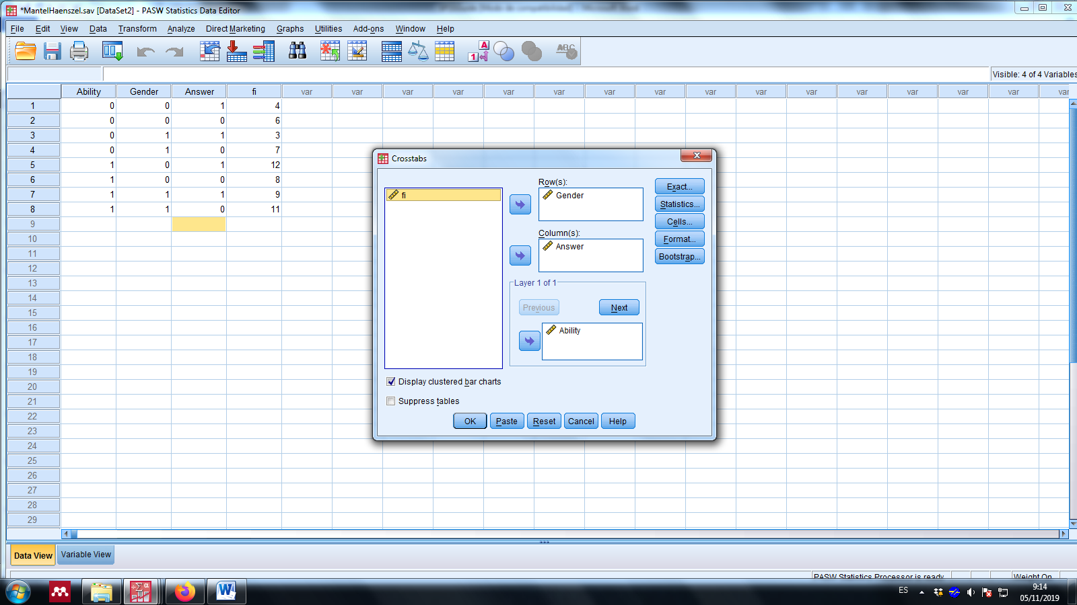

- Data – Weight cases – Weight cases by - f_{i}
- Click Analyze.
- Drag the cursor over the Descriptive Statistics drop-down menu.
- Click on Crosstabs.

- Click on the "grouping" variable or categorical predictor variable to highlight it.
- Click on the arrow to move the variable into the Row(s): box.
- Click on the dichotomous categorical outcome variable to highlight it.
- Click on the arrow to move the variable into the Column(s): box.
- Click on the categorical variable that denotes the different values or "levels" of the condition that is being tested.
- Click on the arrow in the Layer 1 of 1 table to move the condition variable into the box.
- Click “Display clustered bar chart”.
- Click on the Statistics button.
- Click on the Cochran's and Mantel-Haenszel statistics box to select it.
- Click Continue.
- Click OK.

Interpretation:
- The Crosstabulation shows the frequency statistics associated with the analysis.
- In the Tests of Homogeneity of the Odds Ratio table, look under the Asymp. Sig. (2-sided) column. If the p-values are ABOVE .05, then continue with the analysis. If the values are BELOW .05, then researchers have violated this statistical assumption and should run separate bivariate analyses.
- If researchers met the assumption above, then look in the Tests of Conditional Independence table under the Asymp. Sig. (2-sided) column.
If the p-values are BELOW .05, then researcheres have evidence of conditional independence between the groups on the outcome. This means that the association between the predictor and outcome variable is significantly different in the different levels of the conditional variable.
If the p-values are ABOVE .05, then researchers do not have evidence of conditional independence between the groups. This means that the groups do not differ in their relationships with the outcome variable according to what condition they are in.

Lesson 5. Reliability

- Cronbach alpha
- Put all the items in the same sense.
- Calculate one alpha for the global test (considering all the items) and by factors.
Analyze – Scale – Reliability analysis – (maintain Model: alpha) – OK

Lesson 6. Validity
- Validity coefficient (Pearson correlation)
  - Obtain the global score of X: Transform – Compute variable (sum all the items and label the target variable) – OK
  - Correlate X and Y: Analyze – Correlate – Baviariate – Pearson (introduce X and Y in the box) - OK

